**Comilla University**

**Dept. Of ICT, Cumilla**

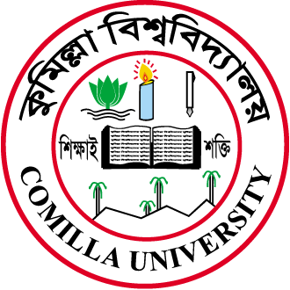

**Project Report On:**

**Submitted By:**

**Hridoy Chandra Das 11809009**

**Md. Inzamamul Haque 11809017**

**Any Chowdhury 11809028**

**Arpita Saha 11809035**

**Rejwan Ahmed 11809036**

**Prome Saha 11809048**

**Under the supervision of**

**Alimul Rajee**

**Lecturer**

**Dept. Of ICT, Comilla University**

***Submission Date: 02 November, 2022***